Sigadd function to add two signals

function [y,n]=sigadd(x1,x2,n1,n2,n3,n4)

n=min(n1,n3):max(n2,n4);

y1=zeros(1,length(n));

y2=y1;

y1(n>=n1 & n<=n2)=x1;

y2(n>=n3 & n<=n4)=x2;

y=y1+y2;

end

Sigsubtract function to subtract two signals

function [y,n]= sigsubtract(x1,x2,n1,n2,n3,n4)

n=min(n1,n3):max(n2,n4);

y1=zeros(1,length(n));

y2=y1;

y1(n>=n1 & n<=n2)=x1;

y2(n>=n3 & n<=n4)=x2;

y=y1-y2;

end

Even part of the signal

function [x,y]=even_part(x1,n1,n2)

[m,k]=sigfold(n1:n2,x1);

[a,l]=sigadd(x1,k,n1,n2,m(1),m(length(m)));

y=a./2;

x=l;

end

Odd part of the signal

function [x,y]=odd_part(x1,n1,n2)

[m,k]=sigfold(n1:n2,x1);

[a,l]=sigsubtract(x1,k,n1,n2,m(1),m(length(m)));

y=a./2;

x=l;

end

Signal shifting

function [w,z] = sigfold(x,y)

w=(-1)*fliplr(x);

z=fliplr(y);

end

1 st bit

Even and odd signal

clear;clc

x=[1 0 0.5 1 1 1];

t=[-1:1:4];

[x2,y2]=even_part(x,-1,4);

[x3,y3]=odd_part(x,-1,4);

subplot(1,3,1)

plot(t,x);xlabel('t');ylabel('x ( t )');title('Input signal')

subplot(1,3,2);

plot(x2,y2); xlabel('t');ylabel('x ( t ) + x ( - t ) / 2');title('even signal')

subplot(1,3,3);

plot(x3,y3); xlabel('t');ylabel('x ( t ) - x ( - t ) / 2');title('odd signal')

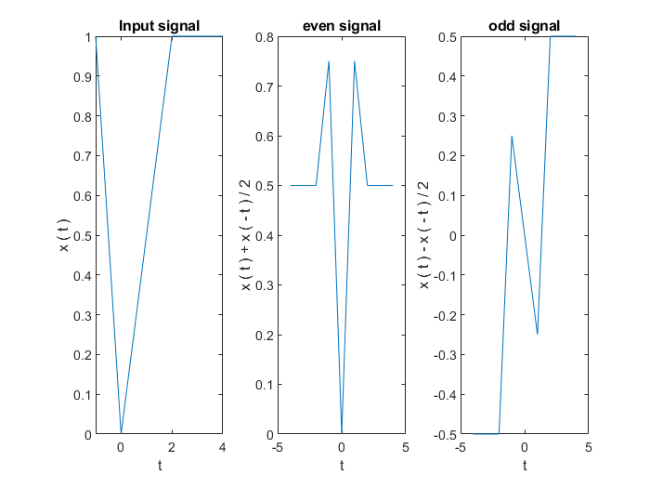

Signal shifting

function [w,z] = sigshift(x,y,k)

w=x+k;

z=y;

end

2nd bit plotting x ( t - 2 )

